call for papers
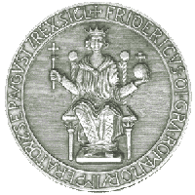

International Workshop
on Cam Transmissions: functional and dynamical aspects
CT2005
October 20 - 21, 2005 Naples, Italy

The aim of the Workshop is to bring together researchers from the broad ranges of disciplines referring to functional and dynamical aspects of Cams Transmission. In particular the optimization of the profiles is associated to a study which takes into account the effects deriving from the lubrication of the organs extended also to the friction and wear phenomena.
CT2005 Workshop is one of the activities of the IFToMM Technical Committee for Linkages and cams

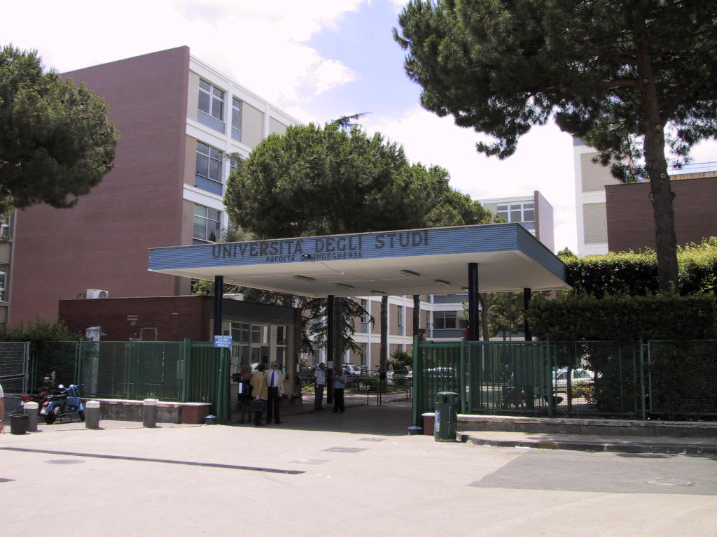

TOPICS
The scope of the topics addressed in the workshop is broad, but within the mechanical transmissions. Papers are solicited on subjects in cam transmissions and are not limited to the following topics:

- Surface profile
- Synthesis algorithms
- Geometrical aspects
- Vibrational analysis
- Tribology
- Kinematic analysis
- Dynamical analysis
- Signal processing
- Wavelet analysis
- Functional analysis
- Computational geometry
- Industrial applications
The Scientific Committee will select fifty manuscripts for presentation at the workshop, which will be published in the Proceedings.

Scientific Committee
Vicenzo Niola (Chairman) Italy
Guido Danieli (Co-Chairman) Italy
Hong-Sen Yan (Taiwan)
Marco Ceccarelli, (Italy)
Carlos Lopez-Cajùn (Mexico)
Hanfried Kerle (Germany)
Geffrey Ge (USA)
Alexander Golovin (Russia)
Vladimir Vaclavic (Slovakia)
Burhard Corves (Germany)
Pier Luigi Magnani (Italy)
Nadar Davishawili
Veniamin Goldfarb

LOCAL ORGANIZING Committee
at University of Naples
Vicenzo Niola (Chairman)
Giuseppe Quaremba (Co-Chairman)
Gennaro Nasti
Roberto Fusco.

Secretariat e-mail: ct05@dime.unina.it

PAPER ELECTRONIC SUBMISSION
Abstract should be sent in PDF format by e-mail before May 20th, 2005 to:
Vincenzo NIOLA (CT2005 Workshop)
DIME, University of Naples
Via Claudio, 21 - 80125 Napoli, Italy
e-mail: vincenzo.niola@unina.it

Please, indicate a session title in which the paper will be properly included. Notification of the acceptance will be mailed by June 10th, 2005. Full paper should be sent in PDF format by e-mail before July 31st, 2005.
Only papers with at least one author as registered participant will be included in the Proceedings CD Volume.

PRESENTATION AND PROCEEDINGS
The official language of the Symposium will be English. The speakers should present their contribution in 15 min. Further 5 min are available for discussion. Slide and overhead projectors, projectors for personal computers, are available for presentation. Registered participants will receive the cd-rom proceedings at the registration desk.

REGISTRATION FEE
The registration fee includes the complete program of the Workshop and the CD Proceedings.
Participants: Euro 250 (before 10 September '05)
Euro 300 (after 10 September '05).
Students and accompanying persons:
Euro 100
Payment should be made by sending a cheque or bank transfer to the Workshop Chairman indicating CT2005 (See webpage).

Web Page
www.dime.unina.it/ct05

INSTRUCTIONS FOR AUTHORS
Guidelines for the manuscript format will be available on the web page. The papers will be written with 10 point characters in one column on an A4 sheet. The length of papers will be limited to 8 pages.

LOCATION
In October the weather is variable, temperatures above 18°C.

ACCOMMODATION
In Naples there are many hotels in all the categories. The average cost for a 3-star hotel is about 70 Euro. Early reservation is recommended by contacting directly hotels or through the CT05 Secretariat. A list of hotels will be sent to the authors and to registered persons.

TRAVEL INFORMATION
Naples can be reached easy both by train , by car and by air. A modern subway and a peripheral private highway assure a fast and easy linkage from the airport/railway station to the workshop site.

Organized by
DIME, University of Naples

Under the auspices
IFToMM T.C. Linkages and Cams

